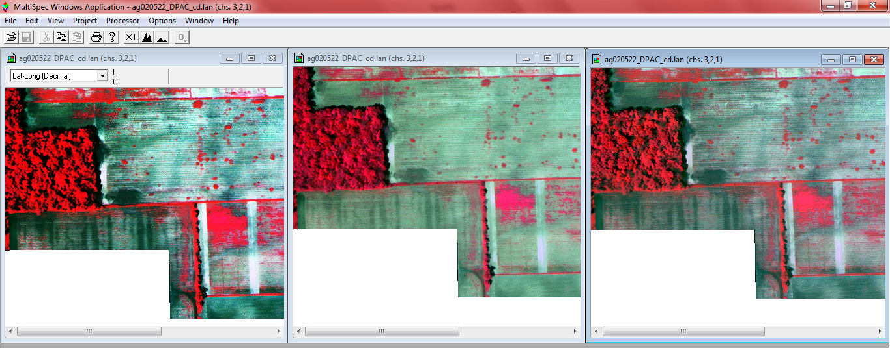
Above you can see images with different levels of gray scale stretch.

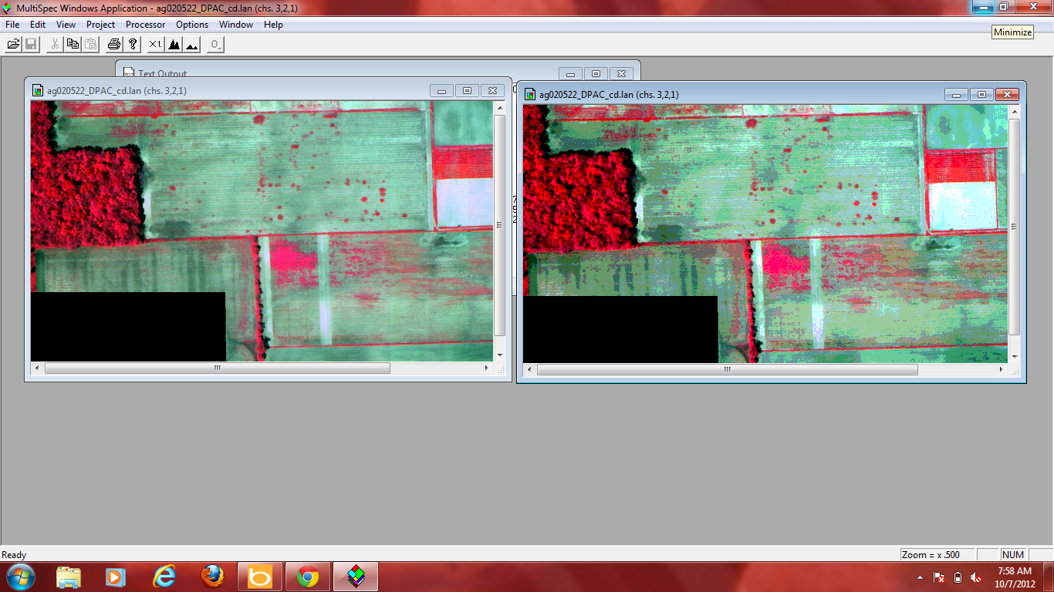

The image on the left shows 256 display levels per channel while the image on the right shows 2 display levels per channel.

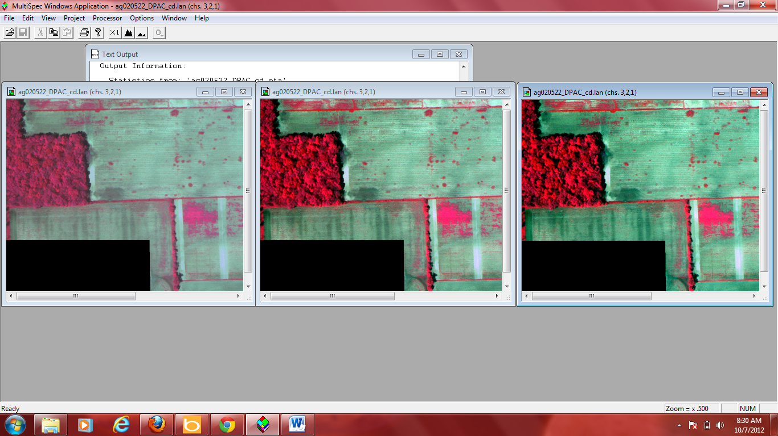

Entire range, 2% clip and 4% clip is illustrated above from left to right.

